  Technology Standards:  3. Research and Information Fluency  Students apply digital tools to gather, evaluate, and use information. Students:  a. plan strategies to guide inquiry.  b. locate, organize, analyze, evaluate, synthesize, and ethically use information from a variety of sources and media.  c. evaluate and select information sources and digital tools based on the appropriateness to specific tasks.  d. process data and report results. | BEginning Sounds  By: Mrs. Greenwell  leandra.greenwell@bullitt.kyschools.us  Grade Level: Kindergarten  Subject Area: reading  Topic: phonics | Standards:  RF.K.3 Know and apply grade-level phonics and word analysis skills in decoding words

- Click on the picture what letter does this begin with? 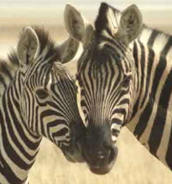

- Click on the picture what letter does this begin with? 

6. Click on the picture what letter does this begin with? 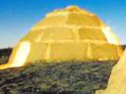

7. Click on the picture what letter does this begin with? 

8. Click on the picture what letter does this begin with? 

9. Click on the picture what letter does this begin with? 

- Click on the picture what letter does this begin with? 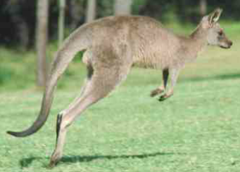

- Click on the picture what letter does this begin with? 

- Click on the picture what letter does this begin with? 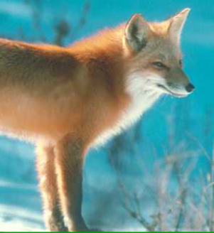

10. Click on the picture what letter does this begin with? 

